**Easy OPC**

1. About the Easy OPC application

Easy OPC application is a software tool for connecting and monitoring OPC (DA/UA) servers. The program also allows you to export data and notify the user about emergency situations.

Functionality of the program:

* Connect to DA/UA servers
* Automatic reconnect after a crash in server connection
* Export data to .CSV files
* Saving the history of changes and generating a report
* User Alert
* Automatic start after rebooting the PC
* Operations Logging

2. System requirements

|  |  |
| --- | --- |
| RAM | 2 GB |
| Available disk space | 300 MB |
| Operating system | Windows 7or later |
| .NET Framework | 4.7.1 or later |

3. Installation

Download the latest version of the program from the site [https://easyopc.com](https://easyopc.com/) and run the installation file with administrator privileges.

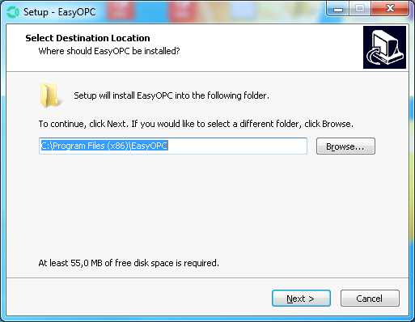

Select the folder in which the program will be installed and click the "Next" button.

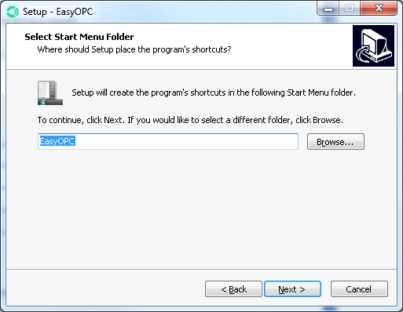

Click "Next".

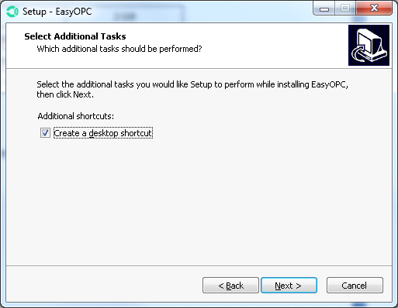

If you want a shortcut to be created on the desktop, select and click the "Next" button.

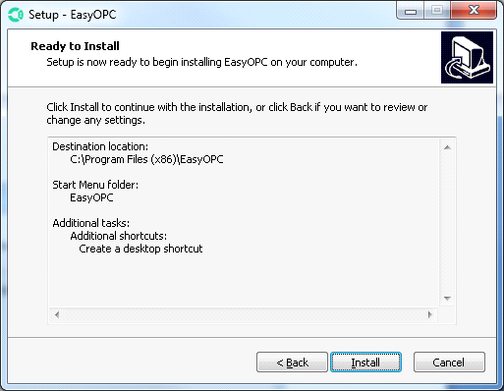

Click "Install".

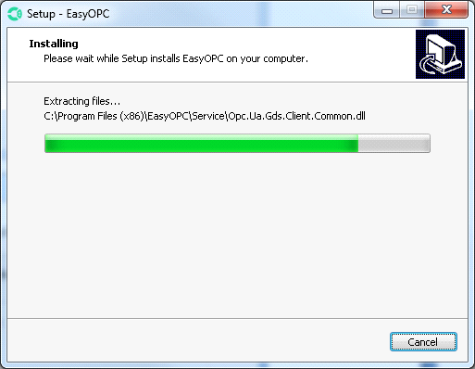

Wait until all operations are completed.

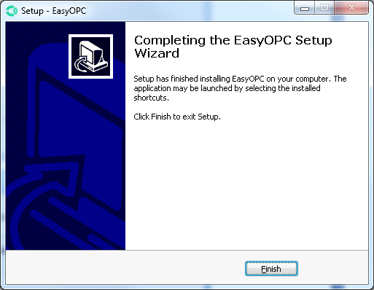

Click "Finish".

4. Working with OPC DA Servers

To add a DA server, you need to click the «Add» button in the DA tab.

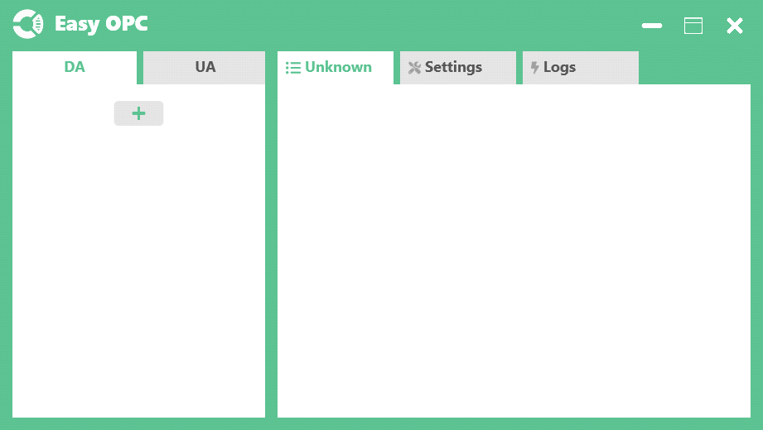

Then you need to specify the server name, host and CLSID (optional). You can also import server connection settings from Matrikon. To do this, select "Import from file" and specify the file with the settings.

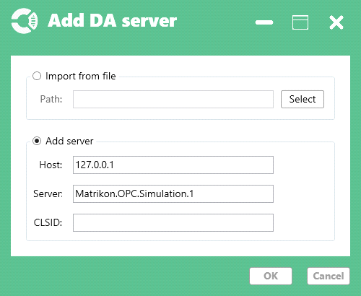

To add a group, you need to select the DA server, right-click and select "Add Group" in the drop-down menu.

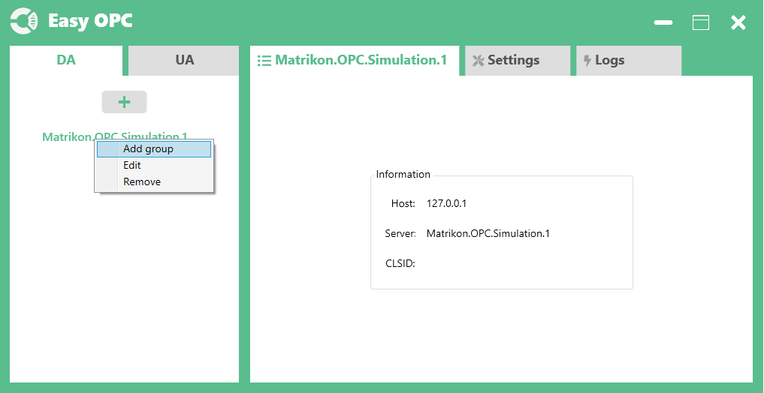

In the add DA group window, you must specify the group name and update period.

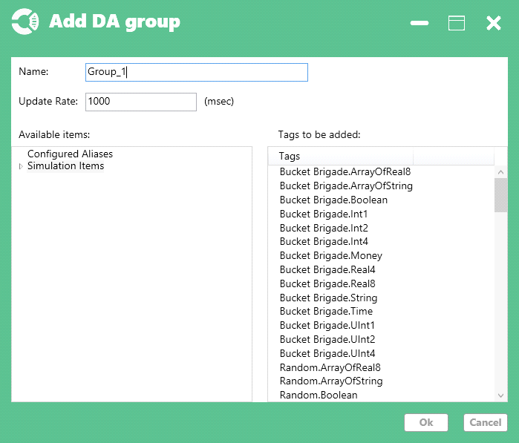

Click "Ok".

Result:

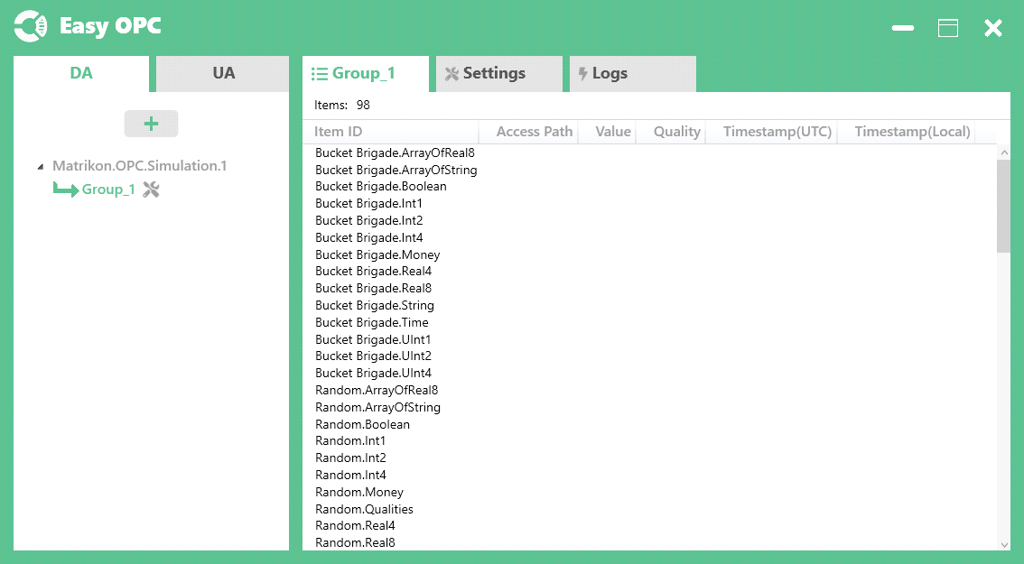

5. Working with OPC UA Servers

To add a DA server, you need to click the button in the UA tab.

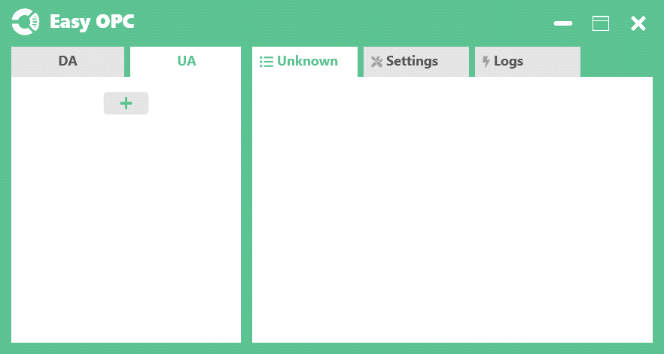

Then you need to specify the server name, URL and Token (optional).

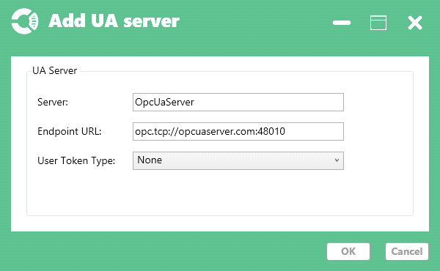

Click "Ok".

Result:

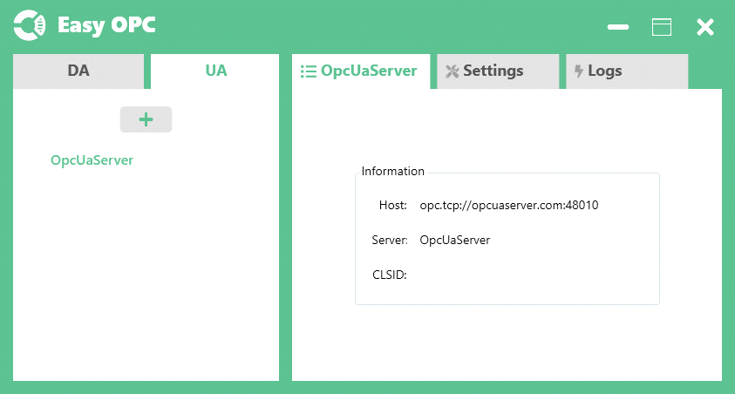

To add a group, you need to select the UA server, right-click and select "Add Group" in the drop-down menu.

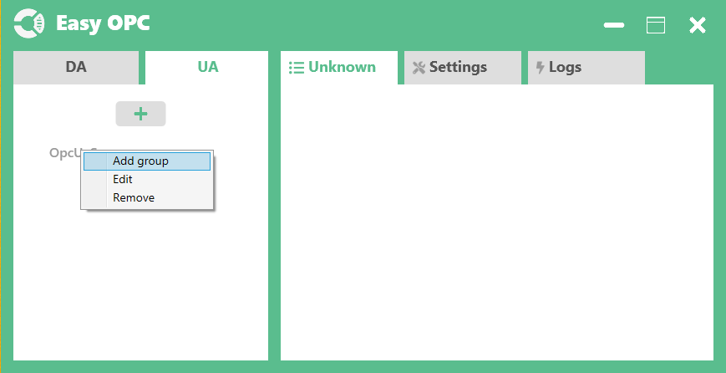

In the add UA group window, you must specify the group name and update period.

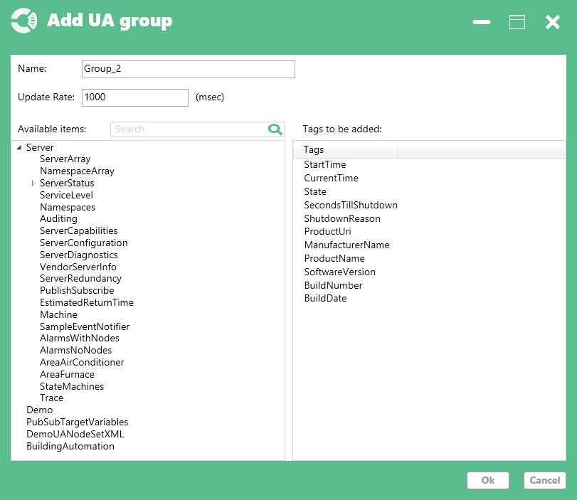

Click "Ok".

Result:

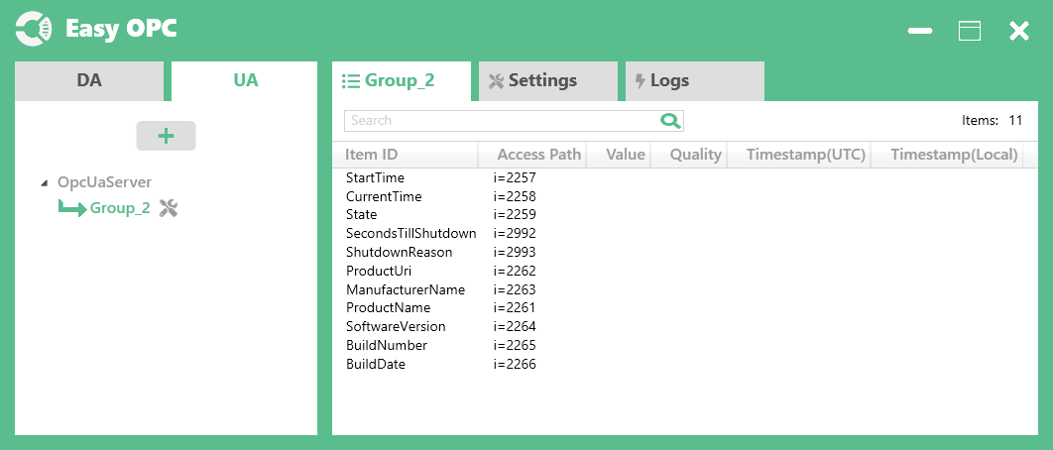

7. History save setting

To enable the function of saving history, go to the group(DA/UA) settings.

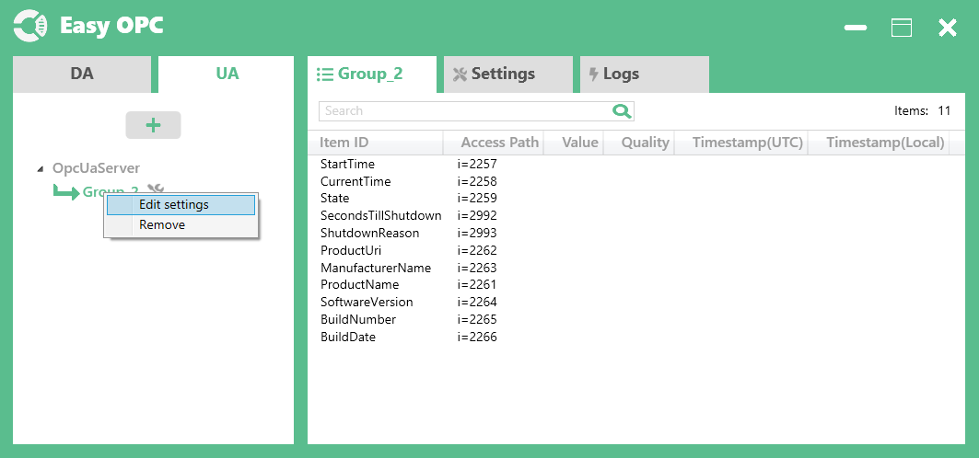

In the window that opens, select the option to «Save the history», then specify the folder in which the history will be saved, then you need to specify the «Timespan» (the period of time that contains one history file) and the duration of the history storage(History retention period).

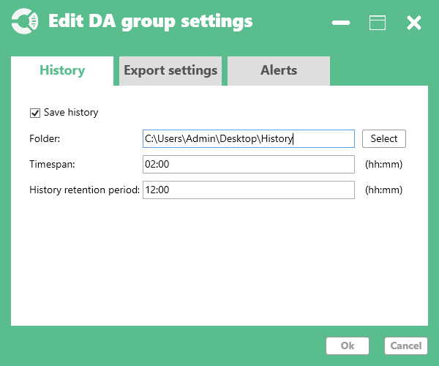

To view the history of changes in the values of an element, select this element, click the right mouse button and select "View history" from the drop-down menu.

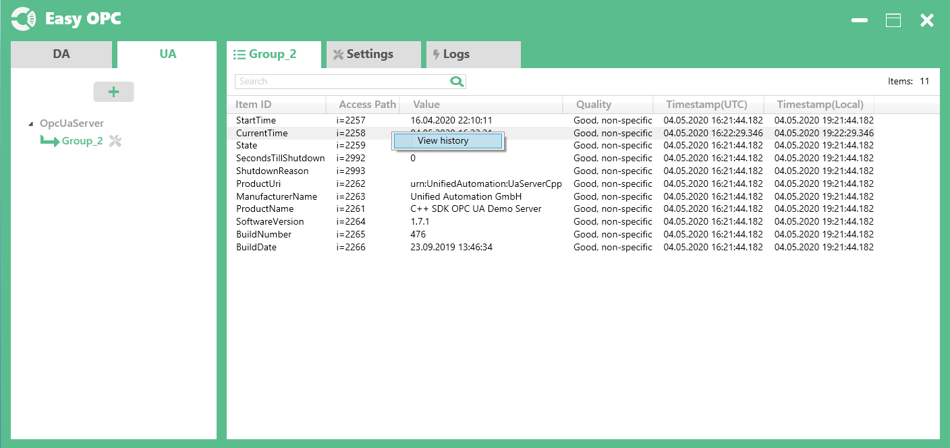

Result:

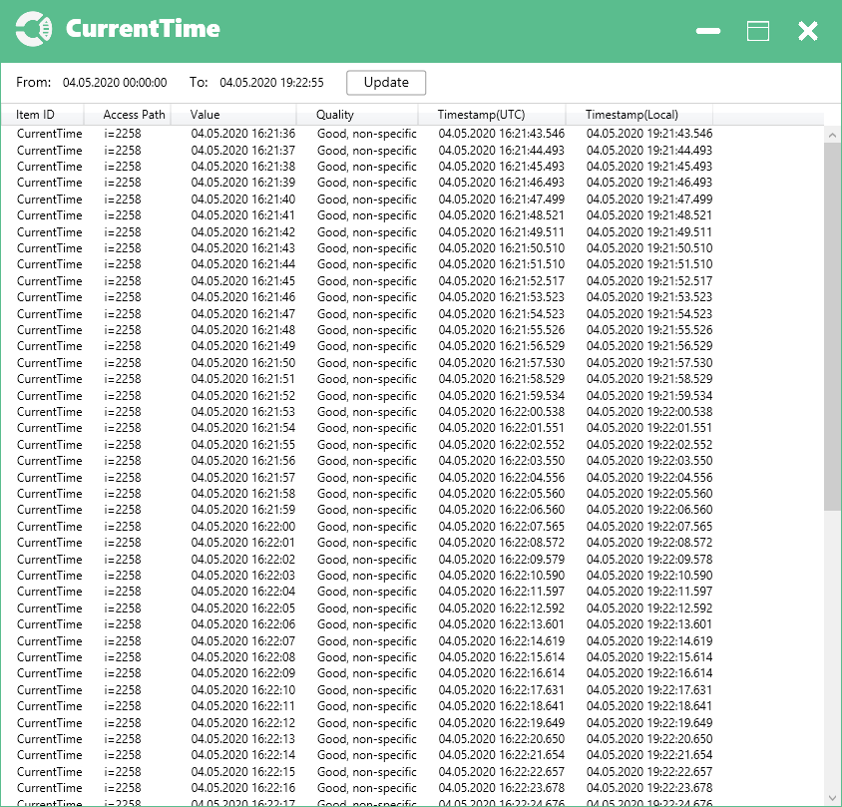

8. Setting export to file

To enable the automatic export function to CSV, go to the group settings (DA/UA)



In the window that opens, go to the tab "Export settings". Next, you need to select "Export to .csv", specify the export period(Timespan) and the folder in which the files will be saved. If you want the export to be performed in the same file, select the "Write in one file" option in which case the file will be overwritten with each export.

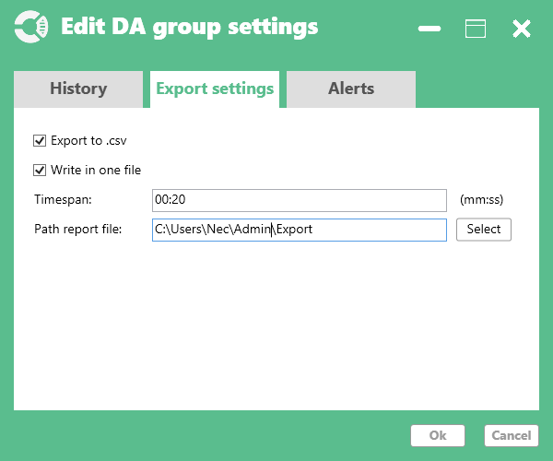

9. Set up alerts

To enable the notification function, go to the group(DA/UA) settings.



Go to the Alerts tab

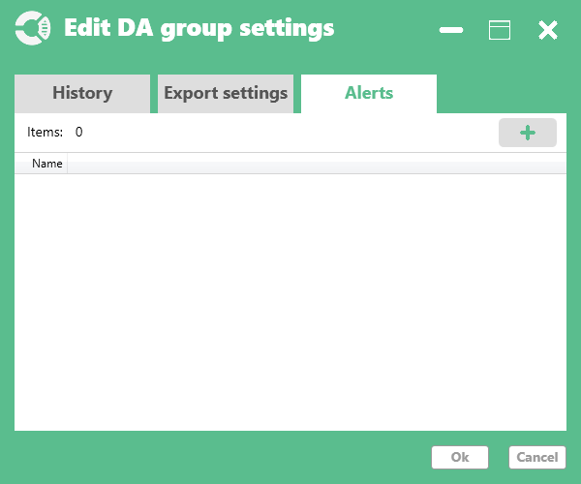

Click the «Add» button and in the window that opens, specify the alert parameters.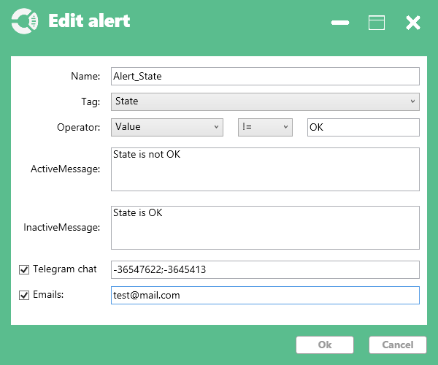

Alert parameters:

* Name - the name of the alert;
* Tag - the name of the tag to which the alert is attached;
* Operator - alert activation condition;
* Active message - message sent upon alert activation;
* Inactive message - a message sent when the alert is deactivated;
* Telegram chat - a list of telegram chats to which messages will be sent;
* Emails - the Email list to which messages will be sent;

Next click OK.

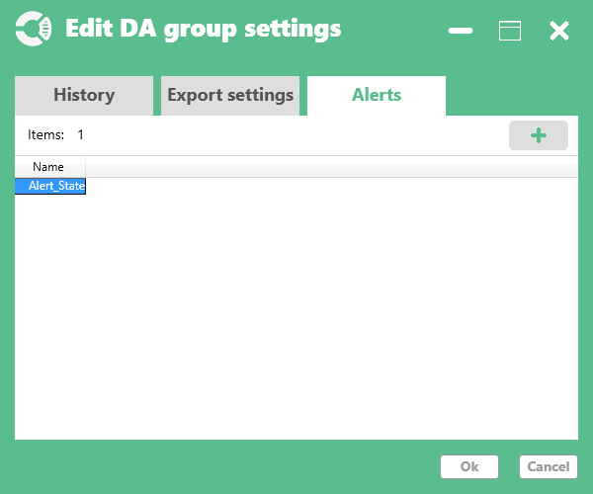

10. General settings: Path to log file

Press the «Select» button and specify the path to the folder where the log will be written.

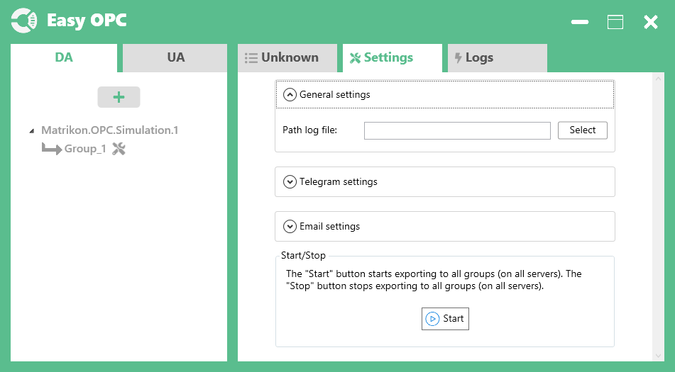

11. General settings: Telegram settings

Specify the token for the telegram bot from which notifications will be sent.

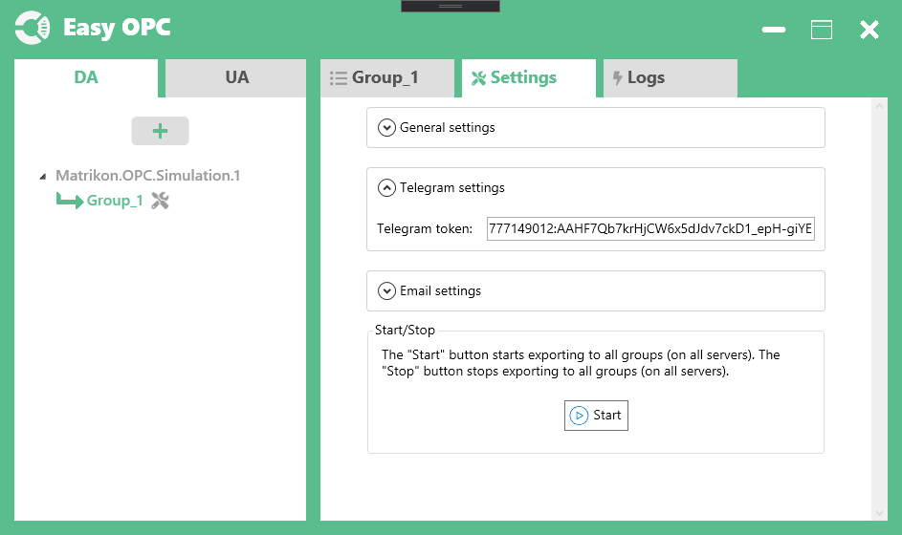

12. General settings: Email settings

Specify settings for access to the mailbox from which notifications will be sent

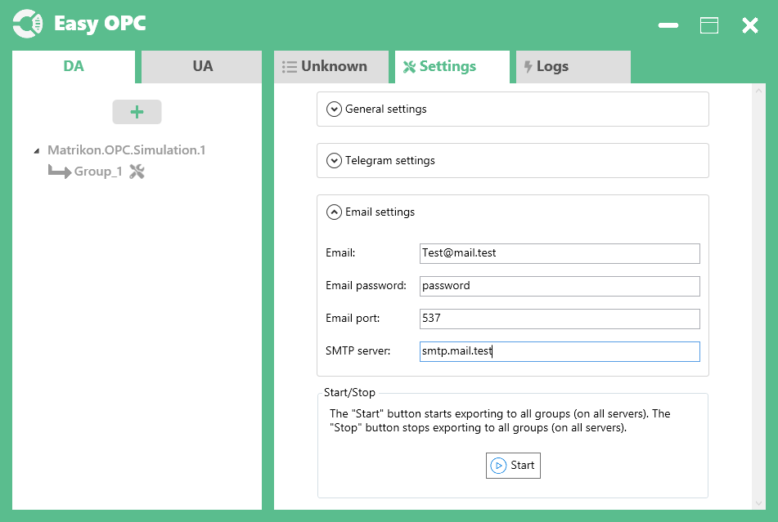

13. General settings: Button «Start/Stop»

The «Start» button starts the monitoring process of OPC servers. 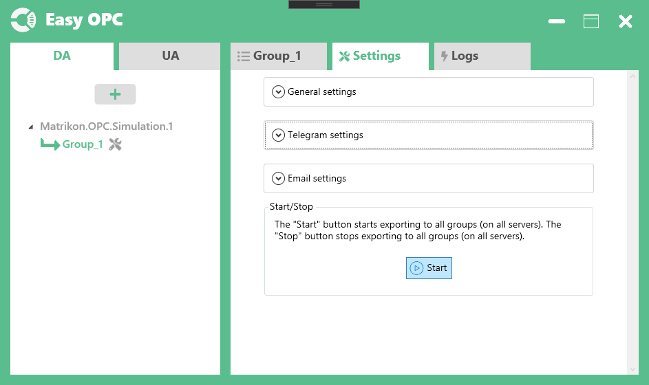

The «Stop» button stops all processes and puts the program into service mode.

